Îndrumător laborator – LUCRAREA NR. 4+

Instrucțiuni

# Exerciții propuse

1. Write an application that allows a user to enter any number of student quiz scores until the user enters 99. If the score entered is less than 0 or more than 10, display an appropriate message and do not use the score. After all the scores have been entered, display the number of scores entered, the highest score, the lowest score, and the arithmetic average. Save the file as QuizScoreStatistics.java.
2. The Freemont Automobile Factory has discovered that the longer a worker has been on the job, the more parts the worker can produce. Write an application that computes and displays a worker’s anticipated output each month for 24 months assuming the worker starts by producing 4,000 parts and increases production by 6 percent each month. Also display the month in which production exceeds 7,000 parts (when the worker deserves a raise!). Save the file as IncreasedProduction.java .
3. The Huntington High School basketball team has five players named Art, Bob, Cal, Dan, and Eli. Accept the number of points scored by each player in a game and create a bar chart that illustrates the points scored by displaying an asterisk for each point. The output looks similar to the chart in Figure 6-34. Save the file as BarChart.java.

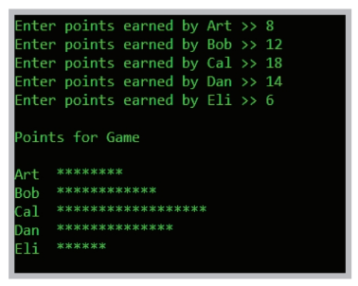

Figure 6-34 Typical execution of the BarChart application

1. Modify the BarChart program to accept the number of points scored by each player in a season. The bar chart displays one asterisk for each 10 points scored by a player. For example, if a player has scored 48 points, then display four asterisks. Save the program as BarChart2.java.